General and Detailed Design
Thuan Nguyen
Nhu Tran
Tuyet Nguyen
Professor Ronald Davis
April 5, 2025
1. Overview of the System of Interest (SOI):
The System of Interest (SOI) is composed of three key subsystems: the mobile application subsystem, the database subsystem, and the backend subsystem. The mobile application serves as a platform where users can explore current events and review past ones, designed exclusively for iOS users due to its single-platform development. The database subsystem relies on the UNA database, which houses essential event details such as dates, times, and records for both upcoming and historical events. The backend subsystem acts as the bridge, facilitating communication between the UNA database, the UNA website calendar, and the mobile app, while also integrating with iOS features like the Reminders and Maps applications. Together, these subsystems form the cohesive SOI outlined below.
2. Description of the Environment:
The environment surrounding the mobile app consists of two main components: the external systems and the technological framework. It encompasses physical hardware, software infrastructure, and the diverse user base interacting with the system. This environment includes UNA’s database, on-campus desktop computers and servers, and internet-enabled mobile devices owned by authorized students, faculty, and staff listed in the UNA database. Administrative oversight of the backend is managed by the University Program Committee (UPC), with occasional support from the IT department.
The primary purpose of the UNA event app is to enable users to browse, submit, and sync events with the UNA calendar. Users can check upcoming events—some open to all, others restricted to specific groups like sorority gatherings or international student activities—and save them to their personal calendars or map event locations via the iOS Maps app. The app also offers features like event reminders, past event searches, and filtering options. Connected to the UNA database and website, the app requires authorized login credentials for access. Event submissions are user-initiated but reviewed by the UPC, which approves, rejects, or modifies postings to ensure accuracy and prevent misuse. The IT department oversees app security, updates, and can monitor the app and pending submissions as needed.
3. Design application components:

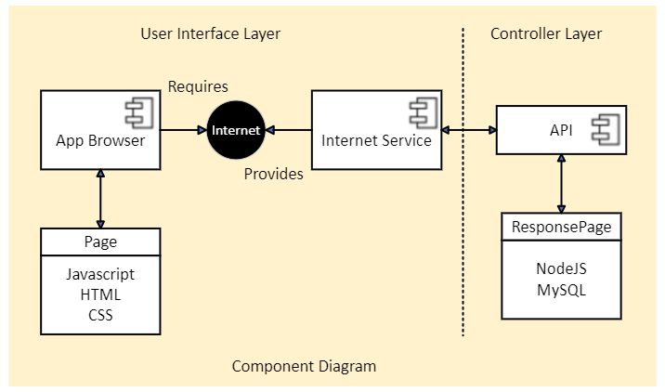
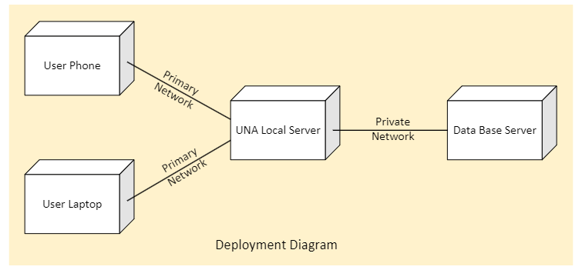
4. Design the user interface:
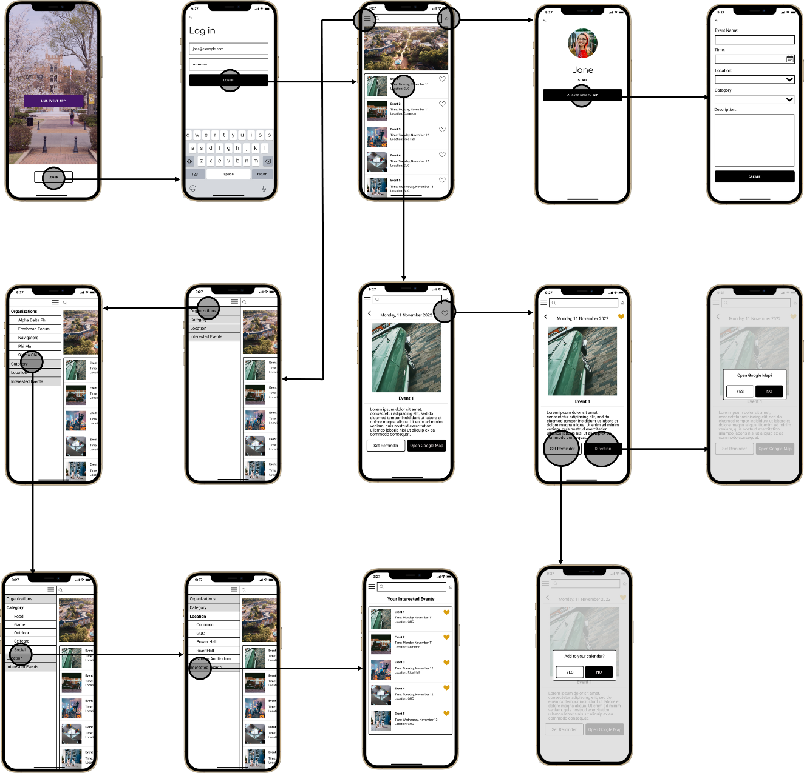
5. Design the database:
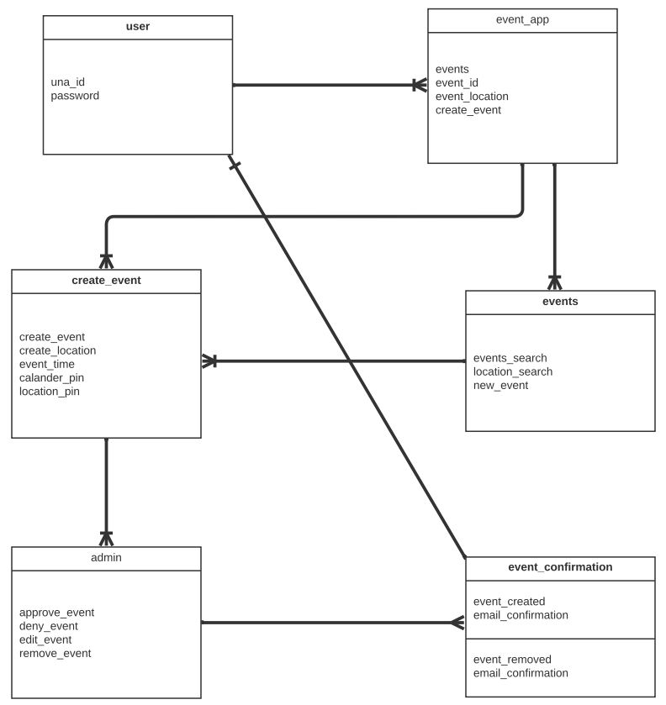
6. Design the software classes and methods:
Class Diagram:
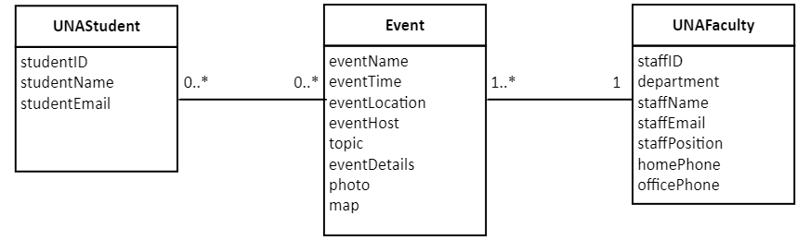
System Sequence Diagrams:
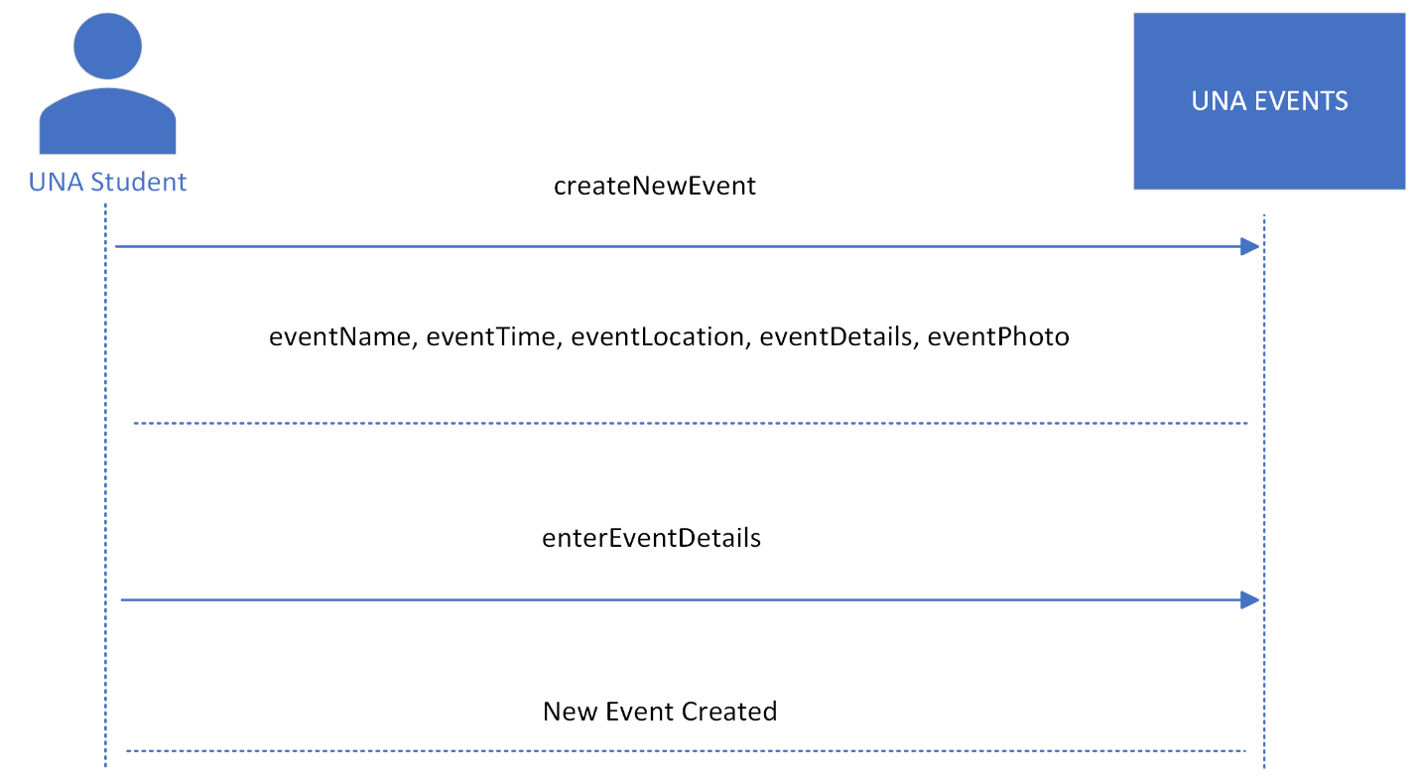
State Machine Diagram:
